Study Space

Design Document

Version 0.1 - 04/07/2017

# Introduction

### Purpose

This design document describes how the requirements for the Study Space application will be achieved. It will go into detail regarding software architecture,

### Scope

This document is constructed to guide the software developers in the creation of the product.

### Definitions

List definitions here.

### References

IEEE Recommended Practice for Software Design Descriptions. Will need to cite it.

### Overview

This document is written adhering to the guidelines outlined by the IEEE Recommended Practice for Software Design Descriptions.

# Decomposition Description

This section shows the decomposition of the system in 3 ways:

* Module decomposition is a breakdown of each module, the data and functions of each class is easy to change, reuse and comprehend
* Concurrent process decomposition explains what the user will be able to see on each page
* Data decomposition explains what is used to store the persistent data.

### Module Decomposition

Package Diagrams

The design of Study Group Finder separates the front end and back end.

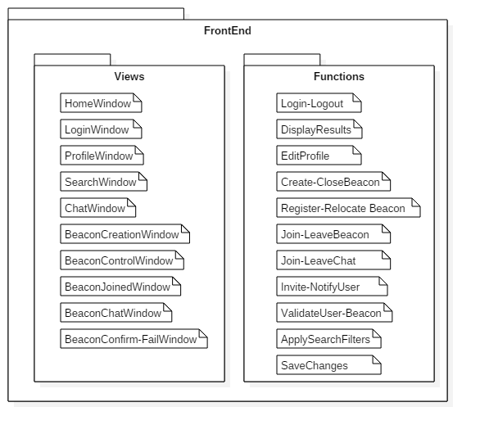

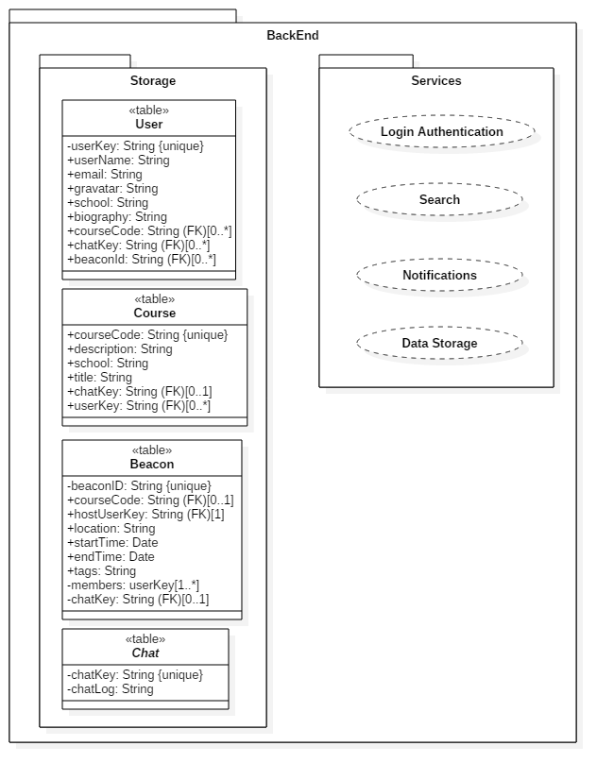

Class Diagrams:

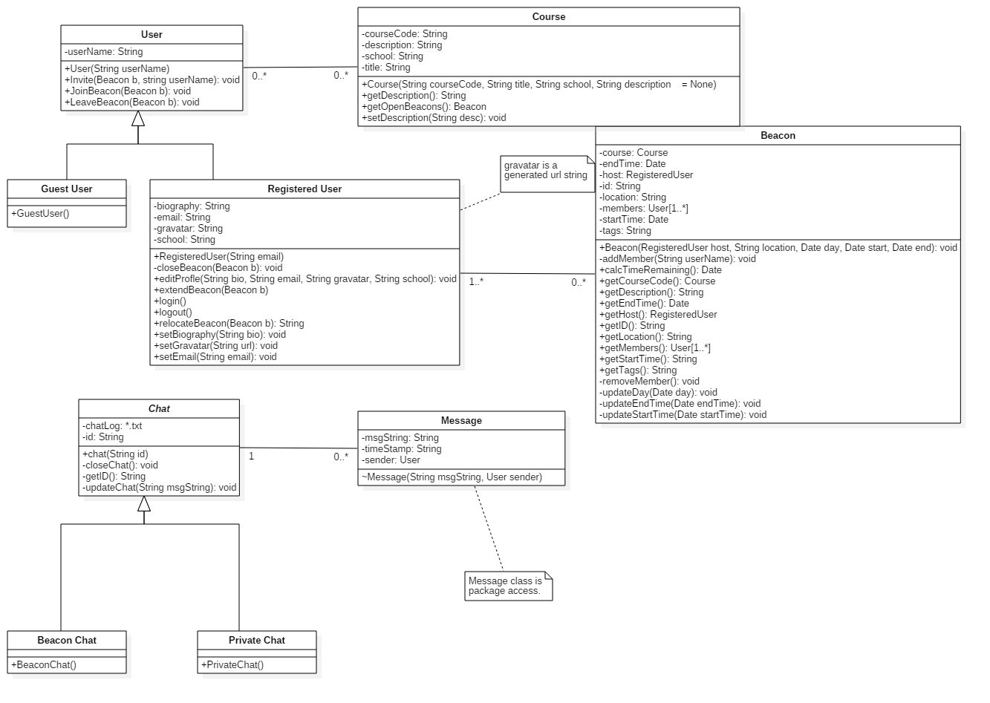

Database Class Diagram:

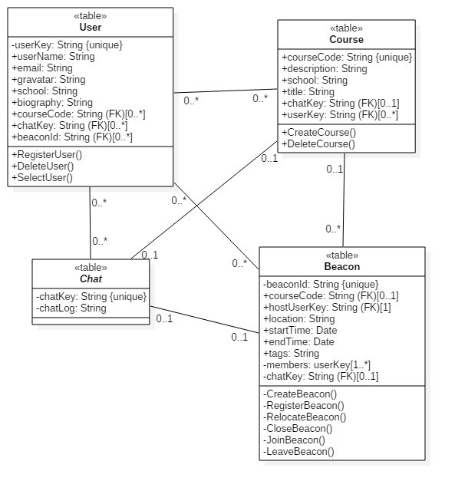

### Concurrent Process Decomposition

HomeWindow:

The main view for the site. Contains a map for easy beacon location selecting on the right side. Has areas for user to input school, course ID, location, date, start and end time and tags.

Also contains already created beacons to join and Login button at the top right corner.

LoginWindow:

Contains the field for Registered Users to input email and password. Also allows users to be able to register for an account. Email, confirm Email, password, confirm password.

BeaconCreationWindow:

Contains the same view as HomeWindow but the list of beacons to join is gone and the inputs for school, course ID, etc are shifted down to be more centered.

ClassDiscoveryWindow:

Contains a list of courses with their respective ratings, quick description and a link to the school page that describes the course.

UserDiscoveryWindow:

Contains a list of users of the site and their profile names, and pictures.

ChatWindow:

A small window at the corner of the screen used to talk to others.

NavigationBar:

A global search bar that will be at the top of each page.

### Data Decomposition

The persistent data is stored with the use of SQL query language.

RegisterUser()

Take all fields disregarding all empty field and putting it into the constructor of the user class. All fields create a new object with the provided fields and saves it to the database. All access is given to this type of user

GuestUser()

A new constructor in the user class that inherits from the User class with a constructor that provides the user with a temporary id that they can join beacons with. This guest is not given access to be able to create beacons

RegisteredUser()

A class that inherits the class User and enables them to access the following interface(Creating a beacon)

# 

# 3.Interface Description

### 3.1Module Interface

#### 3.1.1 HomeWindow

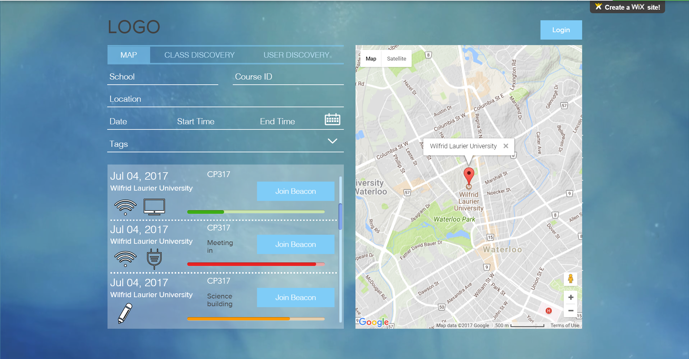

|  |  |  |
| --- | --- | --- |
| **Field** | **Type** | **Description** |
| Login-Button | Button | Links user to the RegisteredUserLoginView |
| School | Text input | School name |
| CourseID | Text input | ID of the user’s course |
| Location | Text input | Location the study would take place |
| Date | Text input | The day in the week(e.g Monday) |
| StartTime | Text input | Time the study group begins(12 hour format)i |
| EndTime | Text input | Time group finishes studying |
| Tags | Drop down input | Chooses from a multi-check box |

#### 3.1.2 LoginWindow

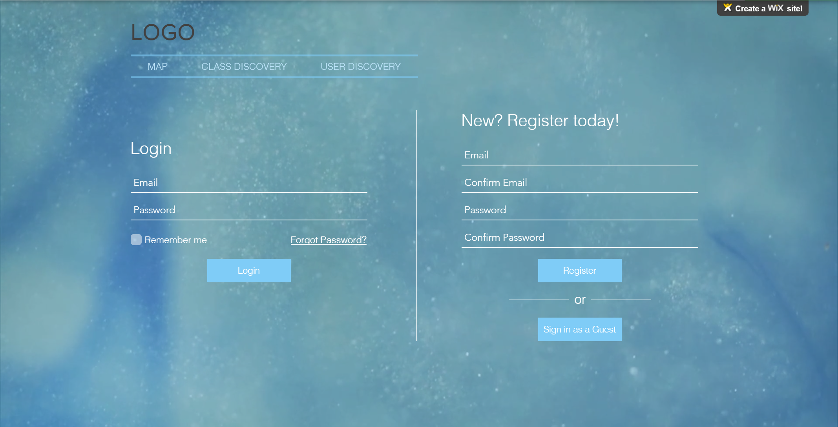

|  |  |  |
| --- | --- | --- |
| **Login Field** | **Type** | **Description** |
| emailInput | Text input | Registered email |
| passwordInput | Text input | Password associated with email |
| loginSubmit | Submit input | Control object to send authorization to provide login |

|  |  |  |
| --- | --- | --- |
| **Register New User Field** | **Type** | **Description** |
| emailInput | Text input | Input unregistered email |
| emailConfirm | Text input | Reenter email entered above |
| passwordInput | Text input | Input desired password |
| passwordConfirm | Text input | Reenter desired password |
| registrationSubmit | Submit input | Control object to send details to database |

#### 3.1.3 BeaconCreationWindow

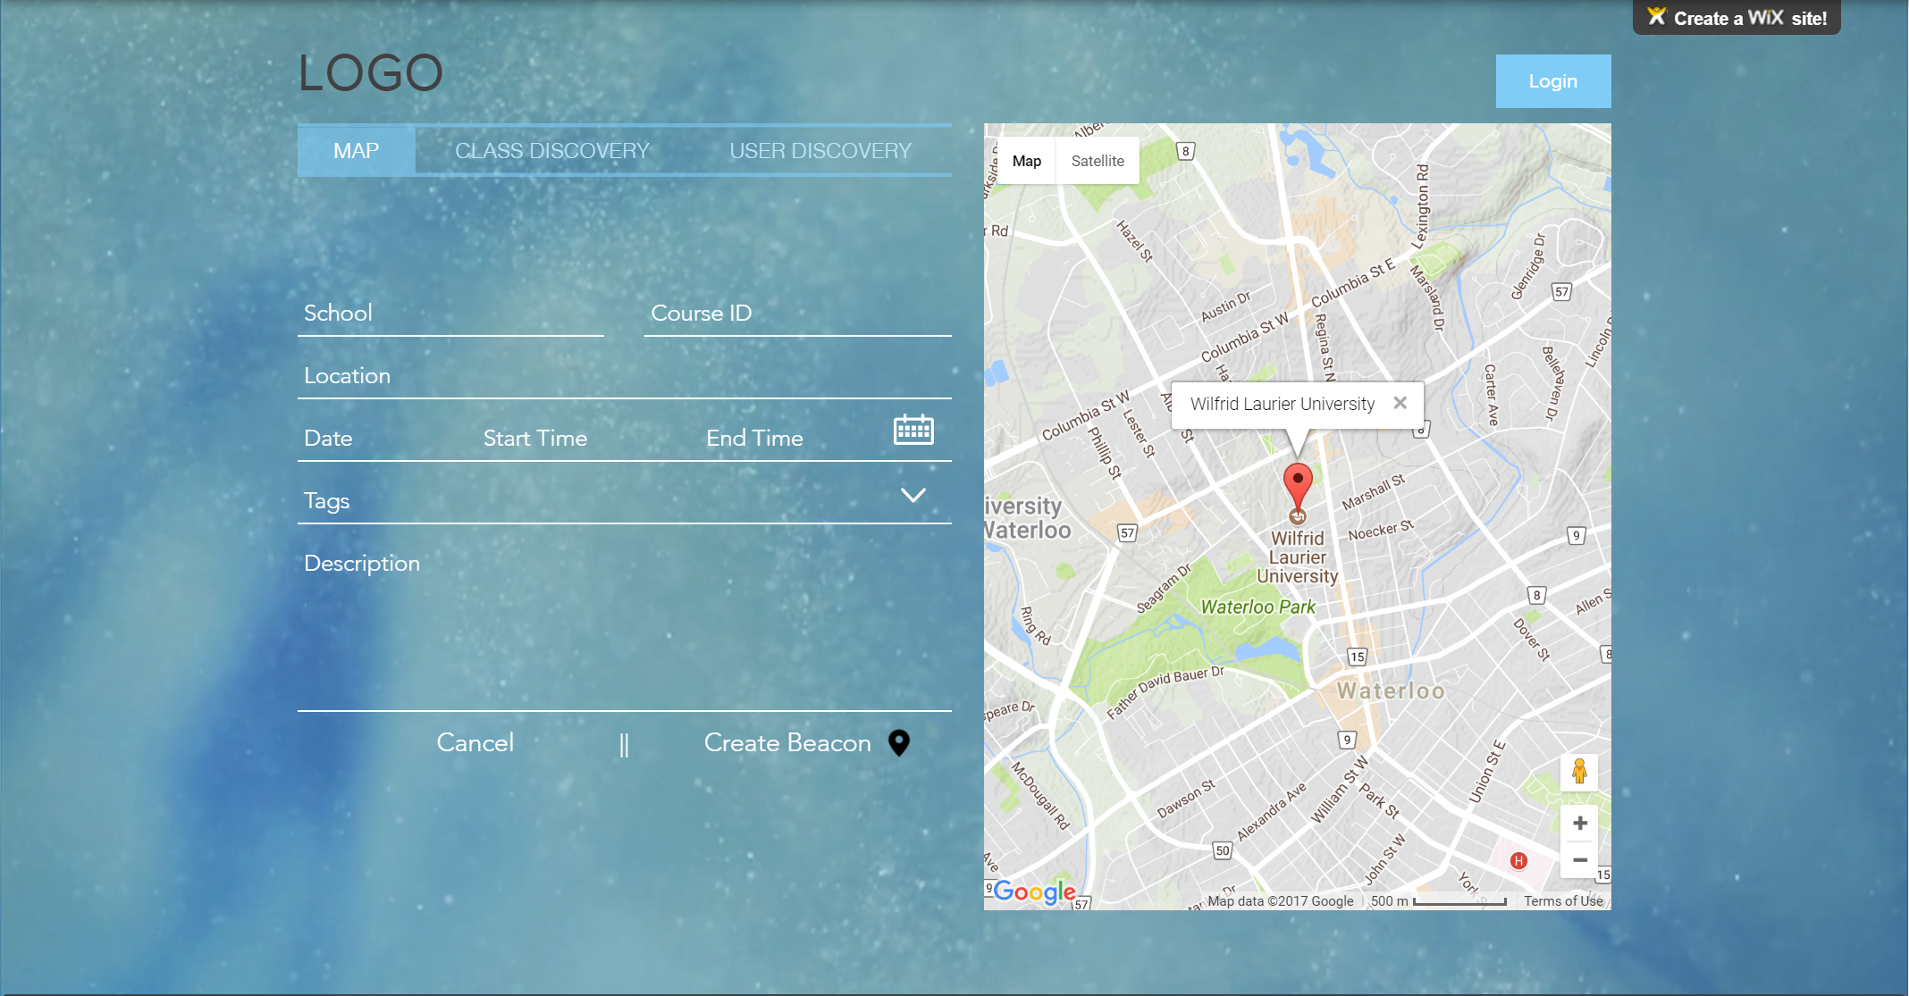

|  |  |  |
| --- | --- | --- |
| **Beacon Creation Field** | **Type** | **Description** |
| beacon-school | Input text | School that the user is studying in |
| beacon-courseID | Input text | Course that the beacon group is studying |
| beacon-timeframe | Input select | Time of when the beacon is going to start and end |
| beacon-location | Input text | Location of where the beacon is going to be taking place |
| host beacon-button | Input button | Registered user attempts to create beacon. Redirects back to BeaconCreateWindow if it fails |

# 3.1.4 ClassDiscoveryWindow

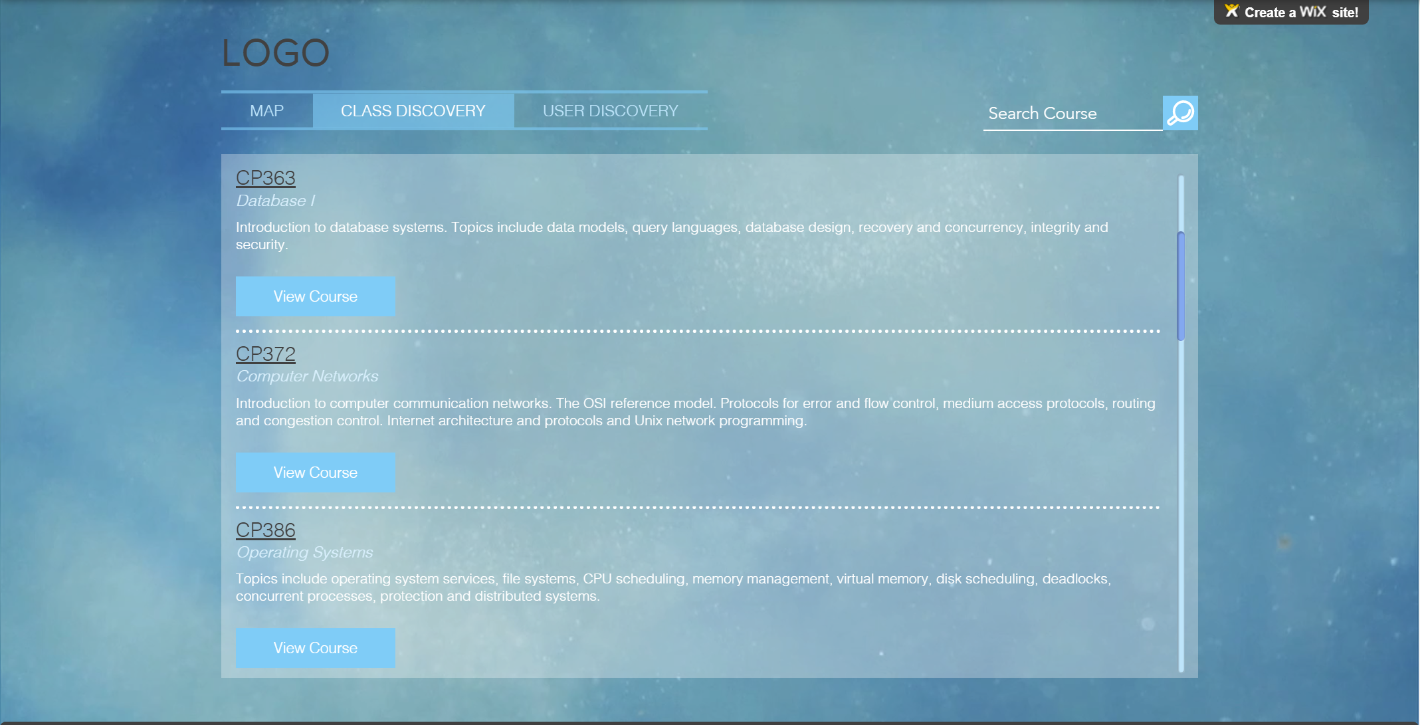

3.1.5 UserDiscoveryWindow

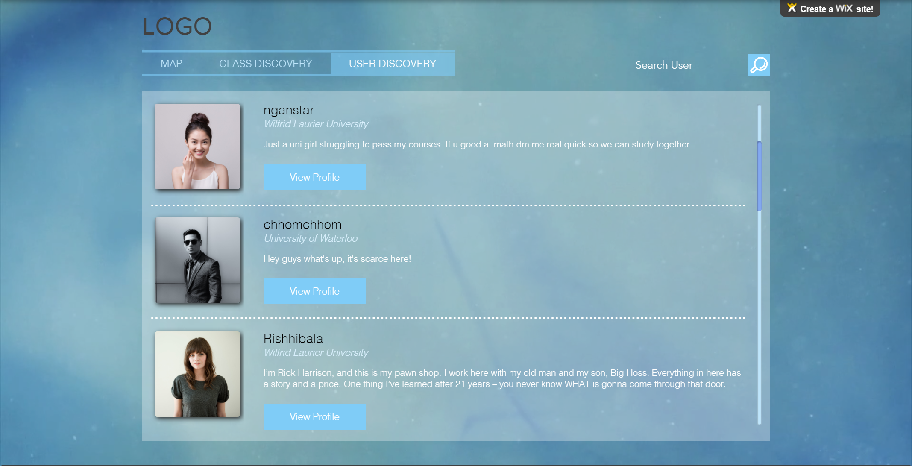

# **4. Detailed Design**

### **4.1 Module Detailed Design**

This section provides a detailed look on module design. It provides steps to produce the intended output of each module in pseudocode. This Pseudocode will be useful for implementation as it provides an outline of which can be used as a guide when developing the product in code.

#### **User Modules**

**Login**

Parameters: None

Description: Logs in a GuestUser to their RegisteredUser account.

1. Call ValidateUser function.
2. If ValidateUser returns true, then log user into their Registered User Account.
3. Else, launch error window. Seems to be none atm.
4. Return to HomeWindow.

**Logout**

Parameters: None

Description: Logs out a RegisteredUser from their account.

1. Log user out.
2. Are we keeping track if user is logged in? Can they be logged in multiple places at once?

**EditProfile**

Parameters: None

Description: Applies changes to a RegisteredUsers Profile. Bad Description

1. Launch the ProfileEditWindow.

**SaveChanges**

Parameters: String biography, String userName, String gravatar, String school

Description: Saves changes made to a RegisteredUser ProfileWindow.

1. Update the UserDB database with the changes.
2. Update the local user profile window.
3. Return to ProfileWindow.

**CancelChanges**

Parameters: None

Description: Cancels changes made to a RegisteredUsers ProfileWindow. (Changes are not applied)

1. Exit the ProfileEditWindow.
2. Return to ProfileWindow.

**ValidateUser**

Parameters: String userName, String password

Description: Validates a RegisteredUser’s credentials upon login.

1. Access UserDB to compare the stored credentials with the credentials that have been input by the user.
2. If credentials match, then return true.
3. If credentials do not match, return false.

#### **Beacon Modules**

**CreateBeacon**

Parameters: None

Description: Creates the beacon. Bad Description

1. Launches BeaconCreationWindow

**EnterInfo**

Parameters: RegisteredUser host, String location, Date start, Date end.

Description: Writes RegisteredUser entered info to the Beacon.

1. User enters info.
2. Call validate beacon.

**ValidateBeacon**

Parameters: RegisteredUser host, String location, Date start, Date end.

Description: Validates Beacon Creation.

1. Check if location is valid.
2. Check if start date is valid.
3. Check if end date is valid.
4. Ensure that end date is after start date, and is therefore valid.
5. If all is valid, call RegisterBeacon. Then launch BeaconControlWindow.
6. If any is not valid call FailedCreation.

**FailedCreation**

Parameters: None

Description: Notifies the RegisteredUser controlling the Beacon of failed Beacon creation.

1. Notify user creation failed. Maybe with a BeaconFailedCreationWindow?
2. Launch BeaconCreationWindow.

**RegisterBeacon**

Parameters: Beacon beacon

Description: Registers Beacon to BeaconList.

1. Add the beacon to the BeaconList.

**CloseBeacon**

Parameters: String userName

Description: Allows UserBeacon to be closed by the RegisteredUser who is hosting the beacon.

1. Remove the Beacon from BeaconList.
2. Close the BeaconControlWindow.
3. Open the BeaconCreationWindow.

**RelocateBeacon**

Parameters: String userName, String location

Description: Allows RegisteredUser controlling the beacon to relocate their Beacon.

1. Use the userName as a key to identify the beacon.
2. Update the location attribute of the respective beacon in BeaconList.
3. Update BeaconControlWindow location value.

**ExtendBeacon**

Parameters: String userName, String date

Description: Allows RegisteredUser controlling the Beacon to extend the time of their Beacon.

1. Use userName as a key to identify the beacon.
2. Extend the date to the date specified.

**JoinBeacon**

Parameters: String userName

Description: Joins a GuestUser or RegisteredUser to a Beacon

1. Use userName as a key to identify the beacon.
2. If beacon is found (if it still exists)
   1. Add user to the beacon’s members list.
   2. Launch BeaconJoinedWindow.
3. If beacon is not found (it does not exist anymore)
   1. Launch BeaconFailedJoinWindow.

**LeaveBeacon**

Parameters: String userName

Description: Removes a GuestUser or RegisteredUser from a Beacon they are in.

1. Use userName as a key to find the beacon in BeaconList

2. Remove userName from the beacon’s member list.

3. Return to HomeWindow.

**NotifyUser**

Parameters: String userName

Description: Notifies GuestUser or RegisteredUser of an invitation to a Beacon.

1. Launch window to notify user of invitation? Or send email?

**ApplySearchFilters**

Parameters: String course, String location

Description: Applies Filters to BeaconList.

1. Generate a temporary filtered list named ‘templist’ from BeaconList based on filters the user has input. Templist will be a list of userName Strings used as keys to identify beacons which follow the filter requirements.

2. Call DisplayResults

**DisplayResults**

Parameters: String templist

Description: Displays results of a search.

1. Use templist as a list of keys to pull information from BeaconList.

2. Use information pulled from BeaconList to display results on HomeWindow.

3. Show HomeWindow.

**BackToSearch**

Parameters: None

Description: Redirects GuestUser or RegisteredUser back to SearchWindow after a failed search.

1. Launch message for failed search.

2. Launch search window.

#### **Chat**

**InviteUser**

Parameters: String userName

Description: Invites another GuestUser or RegisteredUser to Chat.

**JoinChat**

Description: Controller for a GuestUser or RegisteredUser to join a Chat.

**LeaveChat**

Description: Controller for a GuestUser or RegisteredUser to leave a Chat.

**SendMsg**

Description: Controls sending a message to a chat.

This Section describes module design in depth.

### 

### Data Detailed Design

### Documentation

5. Design Description Information Content

* Requires precise design information needed for planning, analysis and implementation of the software system.

**FrontEnd:**

**Frameworks: Angular, Node.js, MaterializeCSS, GoogleAPI**

**Backend**

Languages: Javascript, SQL